10000 Lincoln Dr. East
Marlton, NJ 08053-3108

Thursday, March 07, 2024

Dear Faculty Advisor:

Please refer to this memo for clarification on how to get the induction kit(s) to your student(s) from the national office in time for your induction. To assure timely delivery, please contact us at least four weeks in advance before your induction ceremony. The SIR National dues for Fall 2023 are $55 per member for a standard induction kit.

All types of current induction kits:

SIR Lifetime Membership Fee with standard regalia: $55; includes certificate*, cord, access to electronic journal, and pin.
SIR Lifetime Membership Fee with Stole in lieu of Cord regalia: $68; includes certificate*, access to electronic journal, pin, and stole.
SIR Lifetime Membership Fee with Enhanced regalia: $73; includes certificate*, cord, access to electronic journal, pin, and stole.

To process your request, the national office requires the SIR Student Induction Worksheet to be completed; it is attached in this document. It is also available via http://www.sigmaiotarho.org/chapters/chapter-resources.

Your chapter will need to e-mail the SIR Student Induction Worksheet to the SIR National Office via national@sigmaiotarho.org. We accept the following physical payments: institutional check, cashier’s check, or money order made payable to “Sigma Iota Rho Honor Society for International Studies”. We also accept the following electronic payments: Zelle, ACH, and PayPal (a PayPal transaction fee will need to be added to your invoice, if utilizing our PayPal payment method).

ZELLE®:
CHAPTERS
Name: Sigma Iota Rho Honor Society for International Studies
Email address to use: national@sigmaiotarho.org
Add in the memo field:
SIR Invoice # (This will be provided in our email correspondence.)
Sigma Iota Rho Honor Society for International Studies
Zelle® is similar to Venmo. You connect your banking account or debit card to it to send money. If you don't have Zelle® available through your bank or credit union, you can still use it. Simply download the Zelle® app in the App Store or Google Play and enroll an eligible Visa® or Mastercard® debit card. For more information, click on the link below.
How Zelle works
MEMBERS / INDIVIDUALS
Name: Sigma Iota Rho Honor Society for International Studies
Email address to use: national@sigmaiotarho.org
Add in the memo field:
SIR Invoice # (This will be provided in our email correspondence either directly with you, your SIR chapter, and/or your representative (parent/family/friend.)
Member and Individual's name, if different (for instance family member / friend paying in lieu of member), member's name needs to coincide to the member's name as indicated on the induction spreadsheet for eligibility, verification purposes.
Sigma Iota Rho Honor Society for International Studies
Zelle® is similar to Venmo. You connect your banking account or debit card to it to send money. If you don't have Zelle® available through your bank or credit union, you can still use it. Simply download the Zelle® app in the App Store or Google Play and enroll an eligible Visa® or Mastercard® debit card. For more information, click on the link below.
How Zelle works

ACH:
Name: Sigma Iota Rho Honor Society for International Studies
Accounting and Routing numbers available upon request by your chapter's point of contact or your institution's accounting department. It will also be included on your invoice. If you need anything from me to facilitate this payment method, please email me and I will start the process.
PAYPAL
To utilize this payment method the PayPal transaction fee will need to be added to the grand total.
PayPal@: @SigmaIotaRhoHQ
PayPal link: SIR PayPal Link
PayPal QR code:
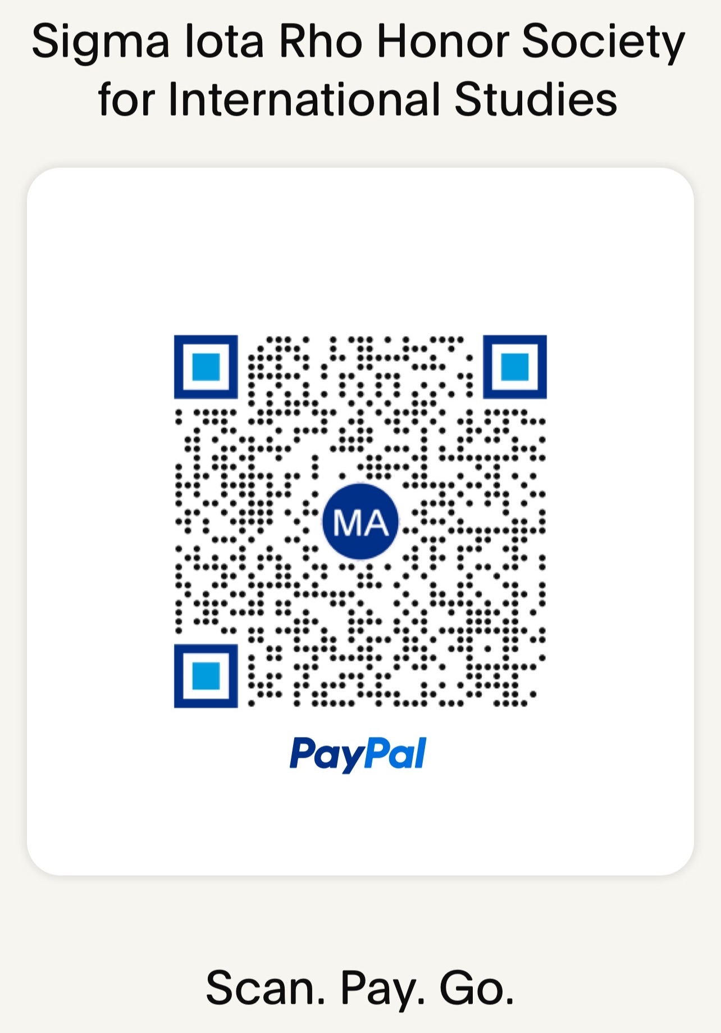

SIR's PayPal QR code steps are as follows:
- Open your PayPal app
- Tap Scan / Pay
- Line up SIR's QR code in the camera frame OR you can scan SIR's QR code right from your camera.
- Enter the grand total amount on the SIR invoice that I will email you and pay via credit card. It would include the induction kit(s) total, expedited shipping (if applicable), and the PayPal transaction fee.
- Hit send

We DO NOT ACCEPT Cash or Personal checks; it will be considered a non-payment. The payment along with a printout of your invoice and/or reference invoice number (preferably) needs to be mailed to:

Sigma Iota Rho Honor Society for International Studies
Attention: Marisol Arcaya
10000 Lincoln Dr. East
Marlton, NJ 08053-3108

On behalf of the national headquarters allow me to thank you for your continuous service to Sigma Iota Rho. We are glad to be working with you and wish for an active and successful year.

Sincerely,
Marisol A. Arcaya
Marisol A. Arcaya
Senior National Liaison Officer, Sigma Iota Rho

